Even Semester (2019)



**BINUS UNIVERSITY**

**BINUS INTERNATIONAL**

**Assignment Cover Letter**

**(Individual Work)**

|  |  |  |  |  |  |  |  |  |
| --- | --- | --- | --- | --- | --- | --- | --- | --- |
|  | | | | |  | |  | |
| **Student Information**: **Surname** | | | | | **Given Names**  **Salya** | | **Student ID Number**  **2201798143** | |
| 1. | | **Wirachman** |  | |
|  |  |
| **Course Code** | **: COMP6510** |  |  | | **Course Name** | | **: Programming Languages** | |
| **Class** | **: L2AC** |  |  | | **Name of Lecturer(s)** | | :1. Jude Martinez  2.Minaldi Loeis | |
|  |  |  |  | |  | |  | |
| **Major** | **: CS** |  |  | |  | |  | |
| **Title of Assignment**  (if any) | : File Archive Tool | |  |  | |  | |  | |
| **Type of Assignment**    **Submission Pattern** | **: Final Project** |  |  | |  | |  | |
| **Due Date** | **: 2-7-2019** |  |  | | **Submission Date** | | **: 2-7-2019** | |

The assignment should meet the below requirements.

1. Assignment (hard copy) is required to be submitted on clean paper, and (soft copy) as per lecturer’s instructions.
2. Soft copy assignment also requires the signed (hardcopy) submission of this form, which automatically validates the softcopy submission.
3. The above information is complete and legible.
4. Compiled pages are firmly stapled.
5. Assignment has been copied (soft copy and hard copy) for each student ahead of the submission.

# Plagiarism/Cheating

BiNus International seriously regards all forms of plagiarism, cheating and collusion as academic offenses which may result in severe penalties, including loss/drop of marks, course/class discontinuity and other possible penalties executed by the university. Please refer to the related course syllabus for further information.

# Declaration of Originality

By signing this assignment, I understand, accept and consent to BiNus International terms and policy on plagiarism. Herewith I declare that the work contained in this assignment is my own work and has not been submitted for the use of assessment in another course or class, except where this has been notified and accepted in advance.

Signature of Students

1.Salya Wirachman

Table of Contents

1. Problem Specification………………………………………………………… 1
2. Solution Design……………...………………………………………………… 2
3. Discussion………………………………………………………………………3
4. Evidence……………………………………………………………………….. 4
5. References……………………………………………………………………... 9

Problem Specification

**Problem**

As CS student we have a lot of files and projects produced from the lecturers and TA sessions about code whether it is notes or its assignments. In the end those leftover files are usually unsorted and assigned by the students and will just be forgotten about until it is needed again and they have a hard time finding it. Meanwhile the files are just there wasting space on the hard drive.

**Solution**

To help solve the problem mentioned above is to create an archiving tool. That compresses and creates a organized place to store projects to.

Solution Design

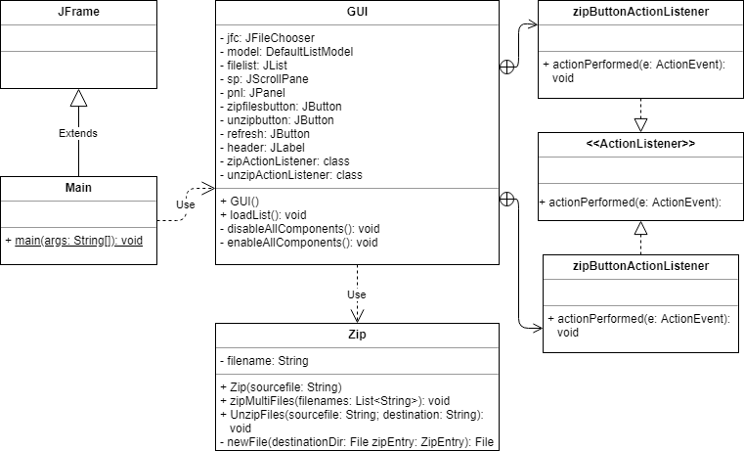

Discussion

Implementation

To run the program, it is made possible with the use of built in libraries in Java. The ones that this project uses is Java.Util.Zip and Java Swing. Other than that, your computer with the newest java SDK and an IDE could run this.

Swing helps in terms of creating an easier access to make graphical user interfaces in this project, it is used to create a window that directly calls the zip functions and the file directory.

Java.Util.Zip is the main compression algorithm used to archive these files. It uses Deflate algorithm. It is a lossless data compression algorithm.

**How it Works**

The User first calls the main function as it creates a separate window using Swing and displays the archived files, an option to archive files and to unarchive or extract them.

If the user chose the zip button, the program then proceeds to open a file directory for you to choose the file(s) that you want to archive. Afterwards it gives the user the option to name the said file(s) in the archive folder.

If the user chose the unzip button, the program asks which file from the archived folder that they wish to extract or unarchive. Then the user chooses the selected file and a window pops up asking for the destination where the unarchived file would go to.

Lastly there’s the Refresh list to refresh the files inside the archive when an update didn’t show in the program.

Evidence

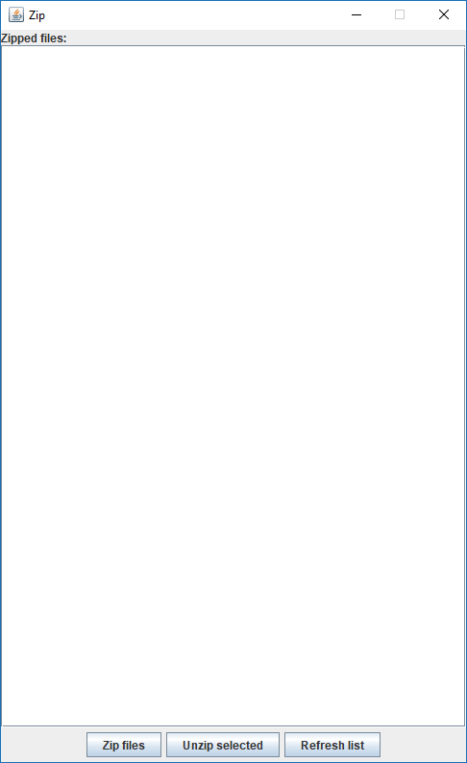

When the program is launched this is the main window that shows the files in the archived folder.

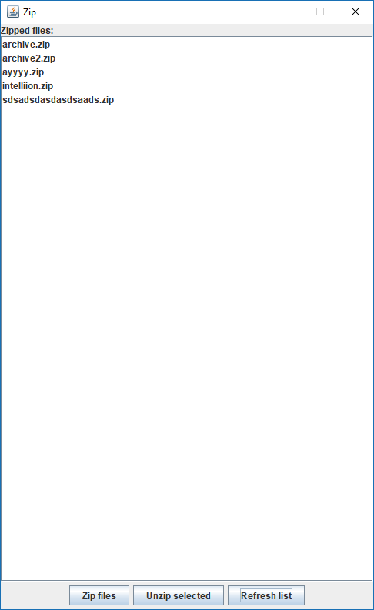

This is what the window looks with files already inside the archived folder.

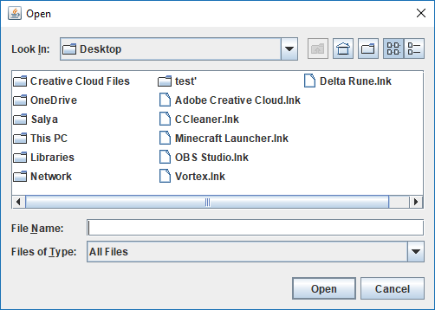

When the user chooses to Zip files, they would be greeted with this window with a file directory asking which files would want to be zipped.

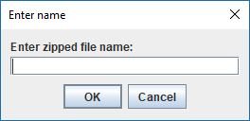

Then it asks the user to name the selected files for the archived folder.

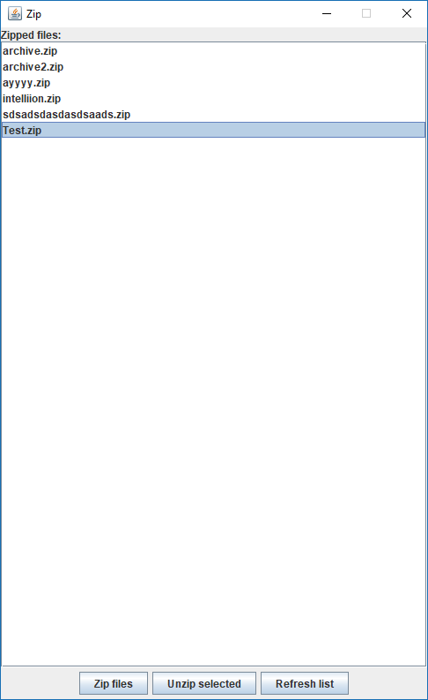

This is what happens when the user wants to Unzip a file.

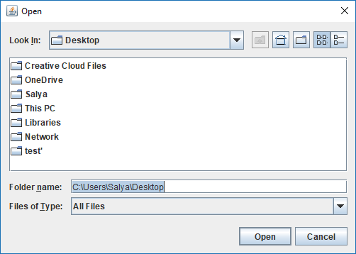

Then the program asks the user where to place the unzipped files.

References

* http://java2novice.com/java-collections-and-util/zip/
* https://www.ntu.edu.sg/home/ehchua/programming/java/j4a_gui.html
* https://www.baeldung.com/java-write-to-file
* https://www.mkyong.com/swing/java-swing-jfilechooser-example/
* http://www.java2s.com/Tutorial/Java/0240__Swing/AddingandRemovinganIteminaJListComponent.htm
* https://docs.oracle.com/javase/8/docs/api/index.html?java/util/zip/package-summary.html
* https://stackoverflow.com/questions/5694385/getting-the-filenames-of-all-files-in-a-folder
* https://www.baeldung.com/java-compress-and-uncompress
* https://www.youtube.com/watch?v=rop0W4QDOUI
* https://github.com/mikepound/mazesolving
* http://www.astrolog.org/labyrnth/daedalus.htm
* https://www.youtube.com/watch?v=zaBhtODEL0w&t=149s